**Test a Perceptual Phenomenon - Stroop Effect**

### **Definition**

Stroop effect refers to demonstration of interference in reaction time of the task. In this experiment, we will compare the two samples gathered using congruent words condition and incongruent words condition. The test shows there is a significant difference in the reaction time of the people in the two cases.

The test consists of two phases:

1] Congruent Words Condition

Reading the color of the ink with which the words are written, given that the color of the words and the word itself are same. Image below taken from [1]

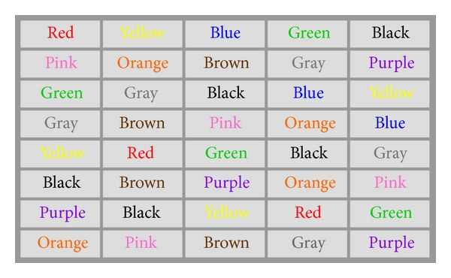

2] Incongruent Words Condition

Reading the color of the ink with which the words are written, given that the color of the ink of the words and the word itself are different. Image below taken from [1]

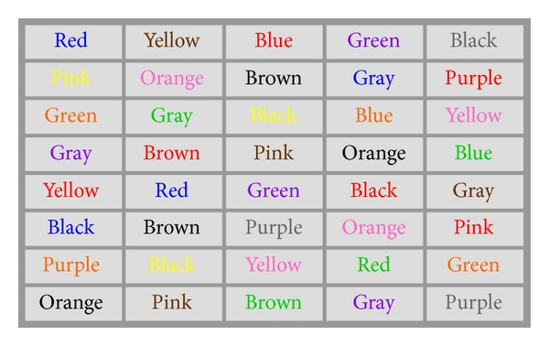

In both the cases, the time duration of the person to read all the words in equally sized lists is measured.

### **Investigation**

Independent Variable – Ink color congruency to word name. In other words, is the test on Congruent Words or Incongruent Words.

Dependent Variable – Reaction time of the person.

### **Hypothesis**

H0 – There is no significant difference in the reaction time of the two tests

𝜇𝑐𝑜𝑛𝑔𝑟𝑢𝑒𝑛𝑡 = 𝜇𝑖𝑛𝑐𝑜𝑛𝑔𝑟𝑢𝑒𝑛𝑡 or 𝜇𝑑𝑖𝑓𝑓𝑒𝑟𝑒𝑛𝑐𝑒 = 0 at alpha level of 0.5

HA – There is a significant difference in the reaction time of the two tests

𝜇𝑐𝑜𝑛𝑔𝑟𝑢𝑒𝑛𝑡 ≠ 𝜇𝑖𝑛𝑐𝑜𝑛𝑔𝑟𝑢𝑒𝑛𝑡 or 𝜇𝑑𝑖𝑓𝑓𝑒𝑟𝑒𝑛𝑐𝑒 ≠ 0 at alpha level of 0.5

Where,

𝜇𝑐𝑜𝑛𝑔𝑟𝑢𝑒𝑛𝑡 = Population Mean from which Congruent Words test sample is derived

𝜇𝑖𝑛𝑐𝑜𝑛𝑔𝑟𝑢𝑒𝑛𝑡 = Population Mean from which Incongruent Words test sample is derived 𝜇𝑑𝑖𝑓𝑓𝑒𝑟𝑒𝑛𝑐𝑒 = Difference in the population Mean of the two samples.

A valid choice of hypothesis is the one, which tries to validate the existence of Stroop Effect. Stroop Effect’s finding [2] suggests that the semantic facilitation displayed in case of congruent words, disappears in the case of incongruent words. Hence, there must be a difference in the central tendencies of the population from which the sample is derived. Here, we try to find, is this difference significant enough to be considered. Since, we cannot take into consideration all the objects in the world (population), we need to work with the samples at hand and use the method of hypothesis and statistical testing to infer the result.

Test Proposed – **Two tailed dependent sample T-test** (Subject Design – Two Conditions).

The selection of T-test is due to the fact that, we are comparing reaction time of a sample from same population in two different conditions and hence coming to a conclusion about the population. Also, considering the skewness of the data and presence of outliers use of t-test ensures the robustness even if the data is not normally distributed. This ensures the violation of assumptions without any significant errors being introduced.

Descriptive Statistics on Datasets

Execute stroop-effect.py and verify the results.

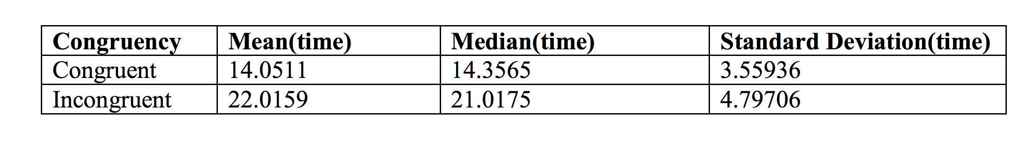

### **Visualize**

The boxplot clearly displays significant difference in the median of the Reaction time of the two samples. It also indicates presence of a longer range of time difference in case of incongruent test sample as compared to congruent test sample.

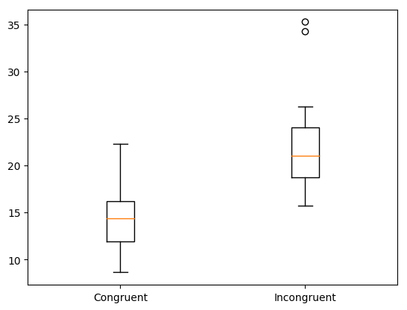

The histogram shows that there is a significant difference in median and mean of the two datasets. It is also evident from the plot that, there are certain outliers in both datasets. The blue dashed line represent the mean of the congruent dataset, and the cyan dashed line represent the mean of the incongruent dataset.

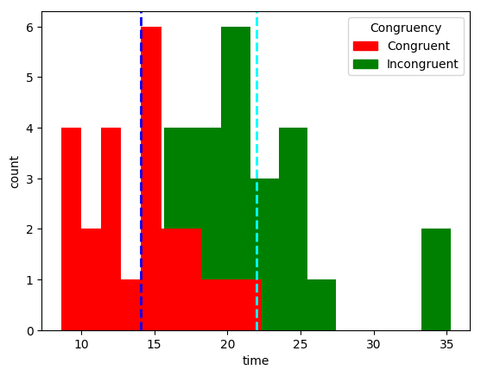

### **Test Result**

𝑡(23) = −8.021, 𝑝 = 0.00, 𝑡𝑤𝑜 − 𝑡𝑎𝑖𝑙𝑒𝑑

𝑡 − 𝑐𝑟𝑖𝑡𝑖𝑐𝑎𝑙 = ±2.069

𝐶𝑜𝑛𝑓𝑖𝑑𝑒𝑛𝑐𝑒 𝑖𝑛𝑡𝑒𝑟𝑣𝑎𝑙 𝑜𝑛 𝑡ℎ𝑒 𝑚𝑒𝑎𝑛 𝑑𝑖𝑓𝑓𝑒𝑟𝑒𝑛𝑐𝑒; 95% 𝐶𝐼 = (−13.48, −2.45)

Since, p-value is much less than, 0.025 for two tailed test, hence, we Reject the Null Hypothesis Ho. Therefore, there is a significant difference in the in the reaction time in the two conditions.

Possible Cause of Effect Observed Considering that color detection is related to pattern detection, i.e., color █ is mapped to word “Red”, this might take longer to process as compared to reading a 3 to 6 letter word as in the test. Also, since in the case of congruent words test, the mapping is directly visible in both reading and pattern recognition context. Hence, it might speed up the process of color recognition causing a significant difference in reaction time between the two tests.

**Example of a Similar Test**

An example of a test similar to Stroop Effect, can be Numerical Stroop Effect [3]. This test takes into consideration the magnitude as well as size (5 5) of the number. Reaction time while comparing digits in congruent trials (7 vs 3) is much faster than comparing digits in incongruent trials ( 3 vs 7)

Bibliography

[1] <https://www.researchgate.net>

[2] <https://en.wikipedia.org/wiki/Stroop_effect#Experimental_findings>

[3] <https://en.wikipedia.org/wiki/Stroop_effect#Numerical>